**Programmable Electronic Load Chroma 63803:**

1. **Specifications**

* Power: 3,600W Voltage: 50 ÷ 350Vrms (500Vpeak) Current: 36Arms (108 A peak )

Frequency: 45 ÷ 440Hz, DC

* Measurement section: DVM: 500V DVM resolution: 10mV

DAM: 160A DAM resolution: 2.5mA

True power: 0 ÷ 3,600W Apparent power: 0 ÷ 3,600VA

Others: Q, CF, PF, Freq, R, Ip- , Ip+ , THDv

* AC input: 115/230Vac maximum VA: 250 VA
* Dimension (H×W×D): 310×430×585 mm Weight: 60kg

1. **Names of Parts**

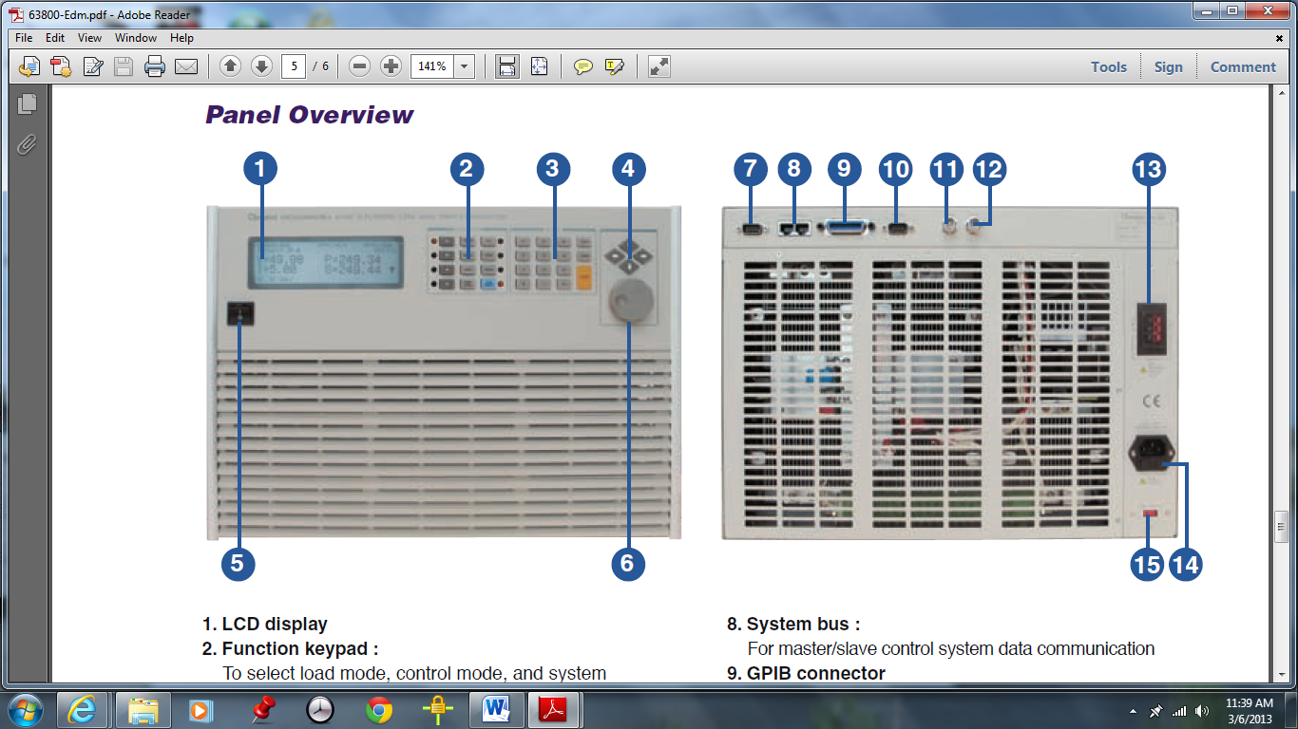

* + Front panel:
    - LCD (**1**): to display configuration, output setup, and measurement results
    - Function key (**2**):
      * Choose the load modes by pressing the CC, CR, CP, CV, RLC/DC RECT and the LEDs aside these keys will be on.
      * CURSOR/EDIT to enable to edit the digit by rotary knob under loading condition
      * RECALL to recall the saved setting from EEPROM that default of CC, CR, CV, CP and PROG files
      * SAVE to save all of the present mode settings in specified files. All saved settings are stored in EEPROM, and will not be lost when ac power is cycled
      * CONF./LOCAL to select configuration data for editing. When in remote control state, this key act as a local key
      * RLC/DC RECT key and the LED aside this key will be on
      * PROG: there is no function so far
      * SHORT: to simulate a short circuit across the input
      * LOAD ON/OFF: to hold on or off the input
    - Entry key (**3**):
      * The user can program numeric data by pressing the numeric keys and the decimal key
      * **+/-** to toggle the sign for those parameters for which it is relevant ex: power factor setting.
      * LOCK: to enables the lock function of rotary or keypad
      * CLEAR to clear the digits entered from keypad
      * ENTER: to execute the value displayed on the LCD
    - There are 4 cursor keys (**4**)to move the cursor
    - Main power switch (**5**): to power on or off
    - Rotary knob (**6**): to input program data or select options
  + Rear panel
    - TTL I/O (**7**): For input/output control signal
    - System bus (**8**): master/slave control system data communication
    - GPIB (**9**): remote control load by using GPIB bus
    - RS-232C (**10**): to transfer control command to and from the PC
    - Voltage monitor output (**11**): analog output proportional to voltage waveform
    - Current monitor output (**12**): analog output proportional to current waveform
    - Load terminal & Voltage sense (**13**): Connect to source or UUT for loading
    - AC input connector (**14**)& AC input switch (**15**)

1. **Turn on E-Load**

Before turning on the E-load, check the following:

* + - * The unit has been set to the correct line voltage
      * The power cord is connected to the AC input socket
      * If the units are employed as 3-phase load, check the connection among 3 (or more) units and setting them as well before loading to the source.

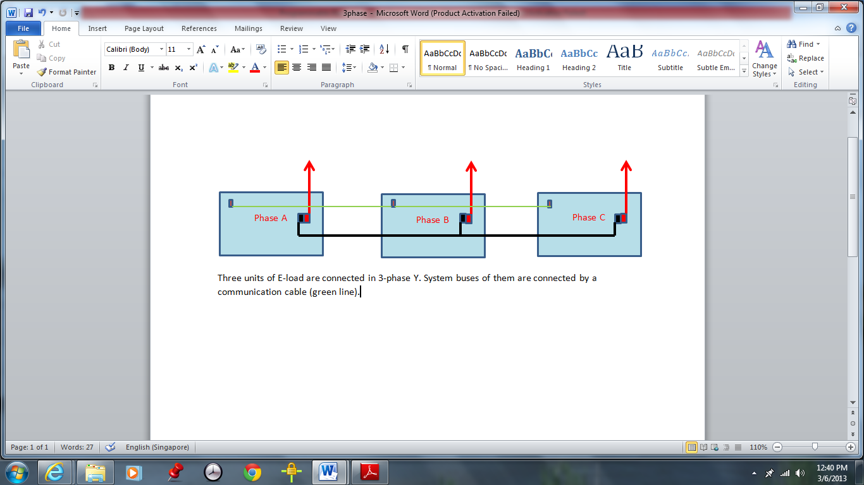

* + - Turn-on self-test: Immediately after turning on, the E-load executes a self-test. The LCD displays the result and then it goes to the output mode setting display. If any error is found in the self-test, the display will stop here.
    - Load connections: The major considerations in making input connections are the current wire size, length and the voltage sense cables. The wires should be as short as possible, and bundle to minimize inductance and noise.

1. **Local operation:**

There are 2 kinds of load simulation for this E-load: AC & DC

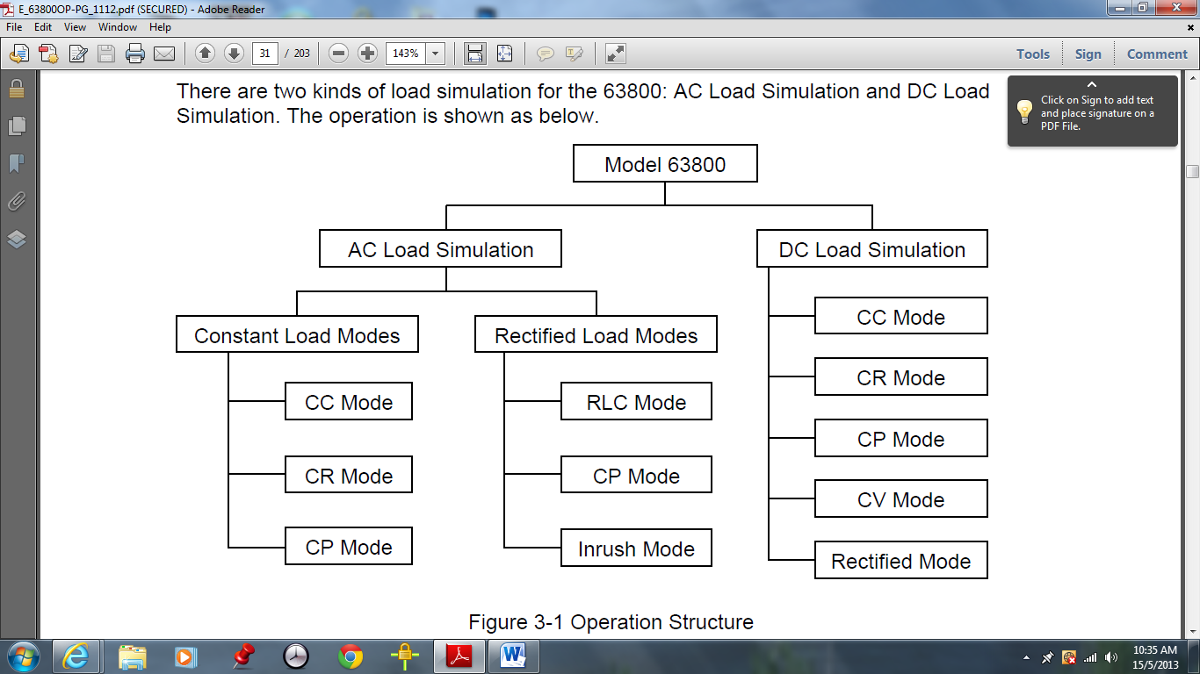

Local control (control by the keys at front panel) is in effect immediately after the power is applied. When E-load is in remote control, It can be returned to local control by pressing CONF./LOCAL.

The operating boundary of power, voltage and current is shown:

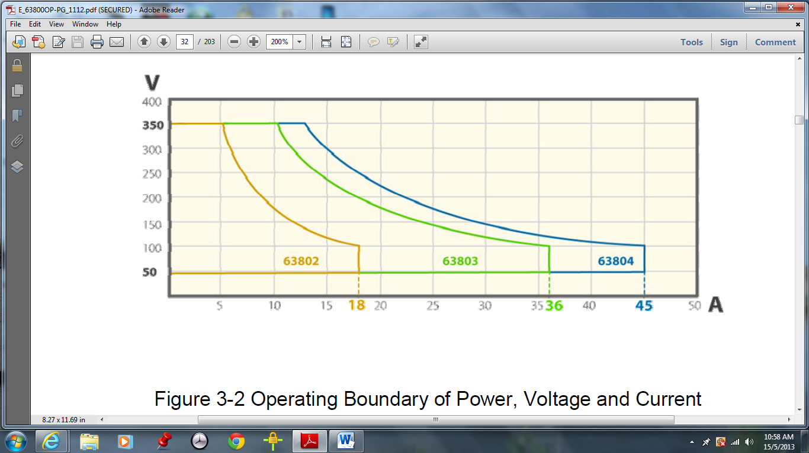

* + - * The display will blink to let you know which setting is to be edited or has been selected.
      * When setting the load level, the resolution of current, voltage, power, resistance and slew rate will be different from the entered values. The output will be the actual value D/A programmed in the load. These parameters except resistance will be degraded to low values when entered.
      * **Setting the configuration**: This procedure is only needed for initial setup of a test operation. The configuration of the load is store in EEPROM. First press CONF./LOCAL; second choose 1; then press ENTER: the screen displays 8 items to setup:
* 1/ Mode select: if AC is chosen, the load will operate in AC mode as well as DC mode.
* 2/ Short: if HOLD is chosen, “short” function will stop when the user release the “short”key.
* 3/ Lockt mode: if KEYPAD is chosen, the keypad will be locked when the user presses the LOCK key. To recover, press LOCK again.
* 4/ Sound: if OFF is chosen, the buzzer will become invalid.
* 5/ CF/PF setting: in BOTH mode, can choose the priority of CF or PF and the other one will change the boundary which will be explain later.
* 6/ Timing mode: if ON is chosen, the timing mode will be enabled. After the load on, timer stops either the voltage is under cutoff voltage or the timer is over.
* 7/ External: if ON is chosen, the e-load can be turned ON by the signal.
* 8/ ABA mode: if ENABLE is chosen, Ip(max) value must be set.
  + - * Display selection: using direction key or rotary knob to choose 4 reading values of measurement shown in the main page, second and third pages.
      * Factory default: recall the default settings for all parameters if “YES” is chosen.
      * Model information: show some information of model.
      * Ip(max) setting and automatic bandwidth adjustment mode (ABA): The Ip(max) has to be set for all mode and it must be reset every time the voltage is gone and appears again. In that case if it has not be reset the display will shows the warning :

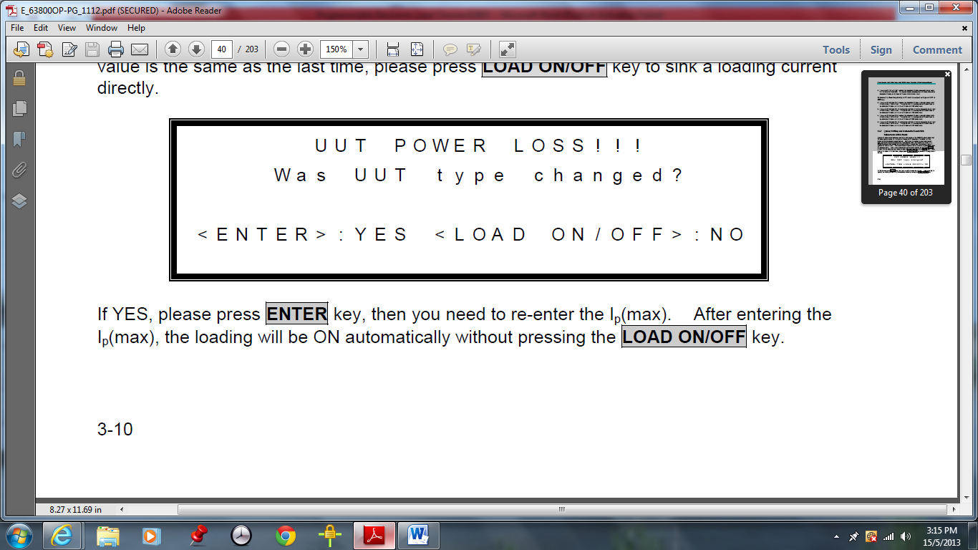

If YES, means want to change Ip(max), press ENTER to enter the edit page, then to key in value and then press ENTER again. The load will be ON automatically.

If No, means the value of Ip(max) is the same as the last time, press LOAD ON/OFF to sink a loading current.

If the LOAD ON/OFF key is pressed under Ip(max)=0, the system will beep twice and then load on with zero loading current.

If the voltage is gone and appears again in two seconds, resetting value of Ip(max) is not required.

If ABA is set to “Disable”, the system may be damaged in the application. So the ABA set to “Enable” is recommended.

* + - * Set mode and parameter values of the load
      * Load ON/OFF: After setting the parameter of the load, press LOAD ON/ OFF key to turn on the load. To turn off, press LOAD ON/OFF key again. The load will be return to the previous programmed values when the load is turn on again.
      * Online change loading: 2 ways:
* By Rotary knob: In load on, when the rotary knob rotates clockwise means increase the value; and when it rotates counterclockwise, means decrease the value.
* By Cursor edit: In load on, press CC, CR, or CP; press Cursor Edit; press directional key to move the cursor to the digit wanted to edit; rotate the rotary knob to change the value; then press cursor edit again to disable the cursor.
  + - * Lock mode: It avoids user to touch keypad or rotary knob unintentionally when operating constantly. Open the “setup screen”; move to “Lock mode”; press the direction key or rotate the rotary knob to choose “Rotary”, “Keypad”, or “All”; then press “Enter”. Press CC, CR, CP or RLC/DC RECT to back to the mode used before and press “LOCK” to lock the item. Press “Lock” again to release the item.
      * The relationship of CF and PF:
    - **AC Load Simulation:** Press CONF./LOCAL and select SETUP by pressing 1 then ENTER. Using cursor keys to choose AC in MODE SELECT then press ENTER. Press CC, CR, CP or DC RECT on function key to choose what kind of AC modes want to load.
      * **CC mode (constant current mode):** to set the condition of CC mode, press arrow key to select the setting parameters: current RMS, PF, Ip(max). For CF & PF parameters if CF only is set, the PF should remain at the CF maximum and cannot be changed. If PF only is set, the CF should remain at PF minimum and cannot be changed. If BOTH is set, it is necessary to set priority. When CF is set as the priority, the range of PF that can be set is limited to the PF range allowed for the CF value according to the figure below. On the contrary, if PF is set priority, the range of CF is limited to the CF range allowed for the PF value set.

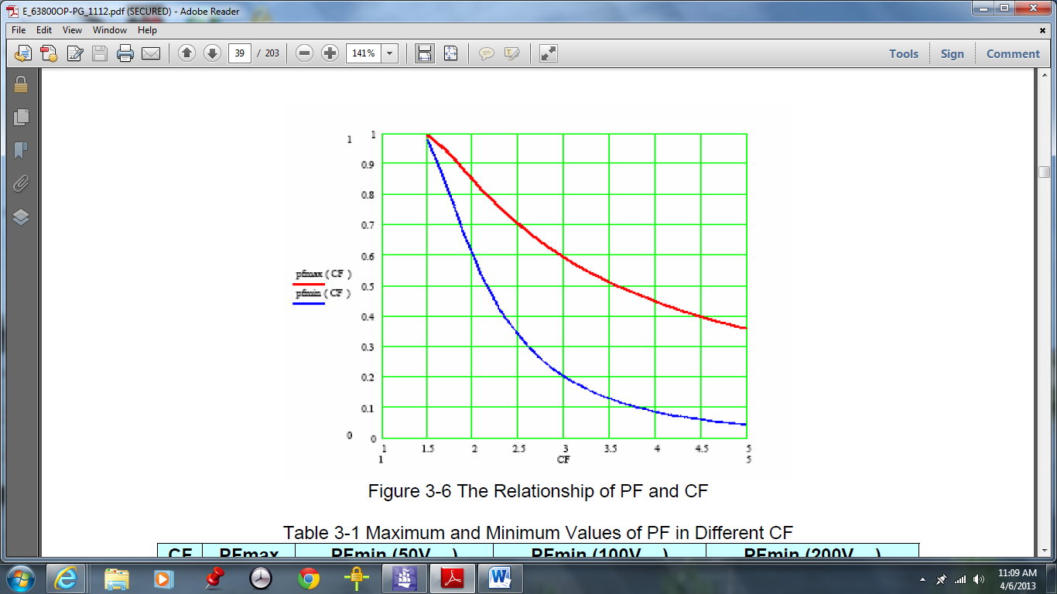

To set to value of CP either CF, firstly press CONF./LOCAL; press 1 then ENTER. Choose SETUP; in setup screen using arrow keys to go to BOTH, CF or PF. If BOTH is selected, a window will pop up to request the user to key in CF and PF priority. Then press CC to back to main page. Press LOAD ON/OFF to run program.

In the main page, the arrow key can be used to select the setting parameters; the type the value with the entry key.

* + - * **Constant Resistance Mode (CR):** inthis mode the PF is 1. To set programmed CR mode is by pressing CR. Then the arrow key to select the parameters on the LCD display such as resistor value and Irms(max).
      * **Constant Power Mode (CP): CP** mode can be set by pressing CP key. Setting parameters on LCD display such as current power value, CF, PF, Ip(max) can be done by arrow key.
      * **Rectified Load Mode**: Is designed into three sub modes- RLC, CP and Inrush Current.
      * **Under AC mode, timing mode can be executed**. Moreover, 63800 also provides the function of measuring transfer time in CR mode. For switching to timing mode, press CONF./LOCAL, press 1 then ENTER. Using arrow key to select MODEL in setup screen. Select TIMING MODE and using direction key or rotate the rotary knob to choose HOLDUP, then ENTER. Press CC, CR, CP to back to main page of timing mode. The transfer time is the time power is disconnected (below 7.5V) and reconnected (above 7.5V). Go to SETUP screen; MODE information; TIMING MODE then choose TRANSFER. Press CR to back to main page. Set Rset and Irms (max). Load on by pressing LOAD ON/OFF. The results will be shown on LCD display when the power disconnect and reconnect.

**5 Remote Operation:** The AC load can be controlled remotely through the GPIB or the RS-232C port.

* + - **Setting the GPIB Address and RS-232C Parameters:** TheAC Load is shipped with the GPIB address set at 8. The address can be only changed from the “CONF” functional list menu. This menu is also used to select the RS-232C interface, and specify the parameters of RS-232C such as baud rate and parity.
    - **Wire Connection of RS-232C:** The AC Load is shipped with the baud rate set at 57600, and with parity set as None. For RS-232C interface, only the signals of TxD and RxD are used for its transfer of data. The following table describes the pins and signals of RS-232C connector.

|  |  |  |
| --- | --- | --- |
| **Pin Number** | **Input/Output** | **Description** |
| 1 |  | +5V |
| 2 | Input | RxD |
| 3 | Output | TxD |
| 4 | Input/output | Short Switch |
| 5 |  | GND |
| 6 | Input/output | Short Switch |
| 7 | Output | RTS |
| 8 | Input | CTS |
| 9 |  | +5V |